Allure and Windows Server 2003
Thursday, April 15, 2004

IIS6 includes new security features that require additional configuration steps in order for Allure to operate properly. Additional details on the changes in IIS6 can be found at http://www.decus.de/slides/sy2003/08_04/1L02.pdf.

There are 2 options for configuring Allure, each of which are detailed below.

Option1 (less secure)
- Change IIS6 to allow all ISAPI extensions to be executed.
- Open the following screen, select “All Unknown ISAPI Extensions” and then click the Allow button.
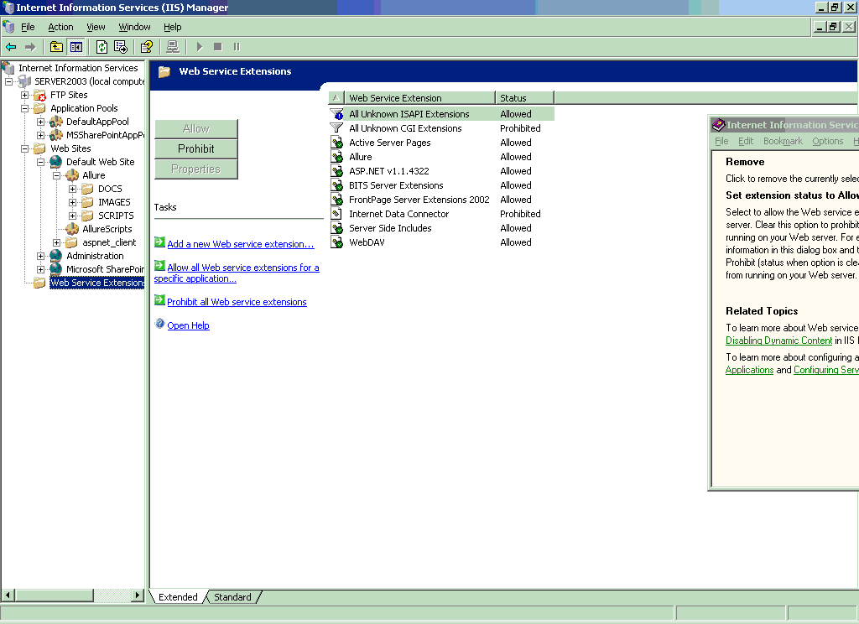

Option2 (more secure)
- Create the Allure web service extension and then Allow only the Allure extension to be executed.
- Copy the ALLURE.DLL file to c:\inetpub\wwwroot
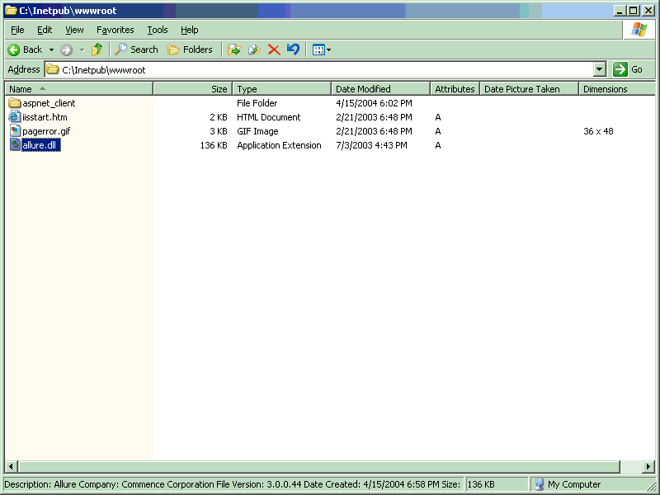
- Create the Allure web service extension by clicking the “Add a new Web service extension…” link. See the screen below for details:
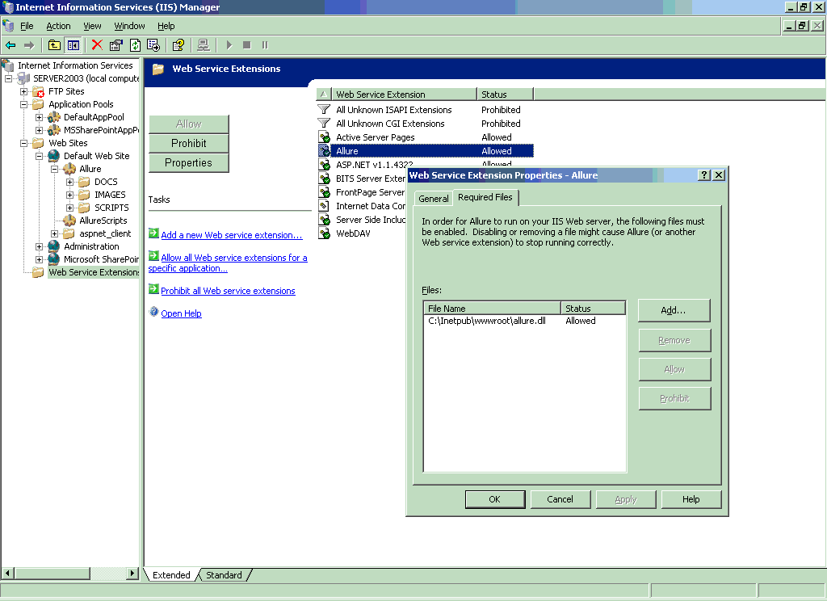
- Select the AllureScripts virtual directory/application and change or add the .ICC mapping to use the c:\inetpub\wwwroot\allure.dll ISAPI file.
